You Show

“A Shipwrecked Sailor”
an excerpt from a retelling of an Egyptian myth

Anen sat on the ship’s deck as the sun sank below the horizon. The pharaoh had chosen him to lead a gold-seeking expedition. He was dreading the pharaoh’s reaction when he would return empty-handed.
“On my first voyage, I was with experienced sailors who were eager to find treasures. One day, while at sea, everything suddenly turned black, lightening streaked across the sky, and the wind roared like an angry lion. A formidable wave smashed the ship against the rocks. All the sailors lost their lives except me. I was seized by a huge swell that hurled me onto a strange island.
Exhausted, I slept on the sandy beach for hours. It must have been the pains of hunger that woke me up, for it was then that I decided to explore the lush, green island.
I had not hiked far inland when I came to a splendid garden. Beautiful tropical birds squawked from tall palm trees, and juicy figs, dates, and coconuts grew in plenty. Strangely, there seemed to be no one to tend this delightful spot.
I enjoyed a meal of fruit while sitting on a carpet of thick, green underbrush. As I wiped the last drops of juice from my chin, I heard thunderous booms and feared another storm. The noise became louder and louder until it was deafening. Suddenly it stopped right in front of me.
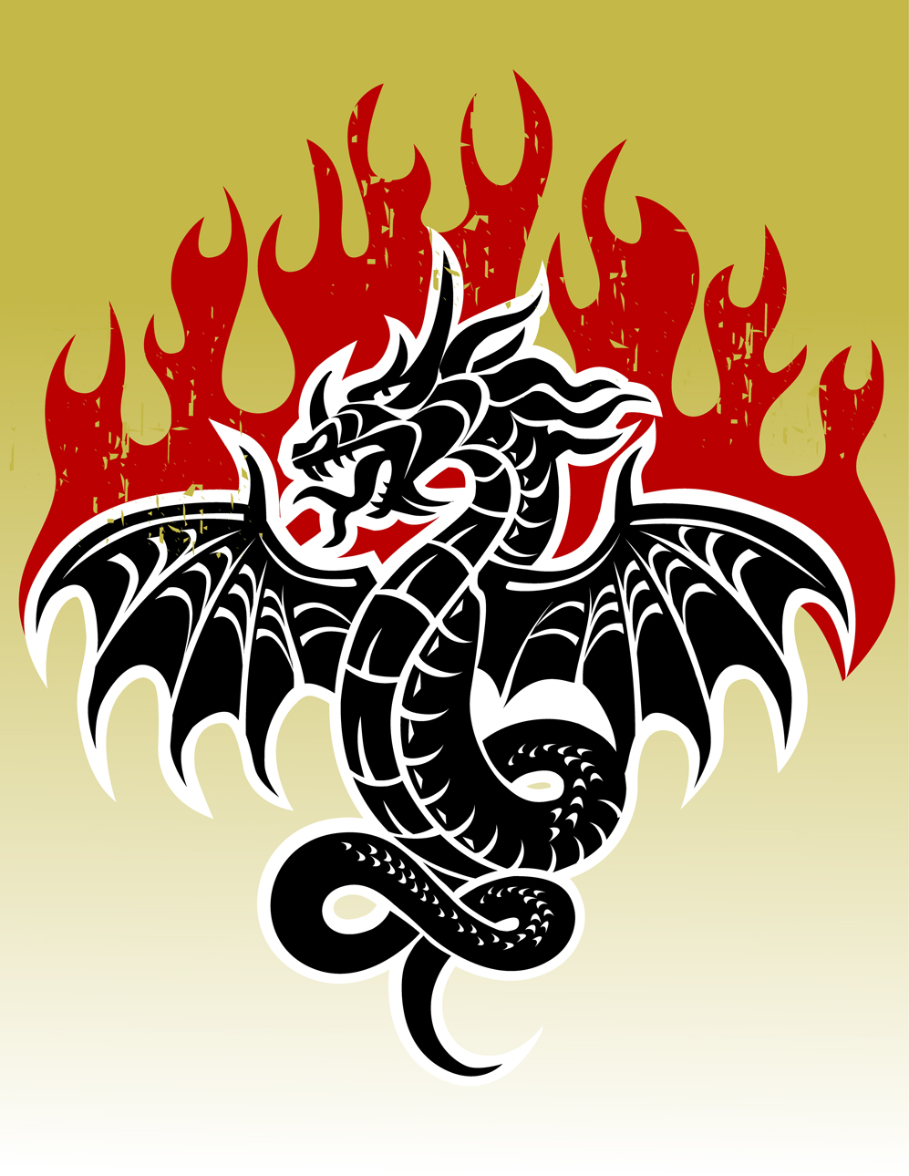
I turned around and saw a monstrous serpent standing upright. The huge creature’s body was covered with golden scales, and the scales around his eyes were as blue as lapis lazuli. “Who brought you here?” he demanded. As he spit out the words, I felt my legs give way and I fainted dead away on the luscious grass!

